Agenda-Display all the products (ex: dresses) along with sort filters (check box) to sort them based on size, and price range (first sort on size, then on price)

Ex: Refer how to search a product in any shopping application by changing various filters

core

to achieve this we need one case type and one data type for storing the info of all the products

I created my data type as below

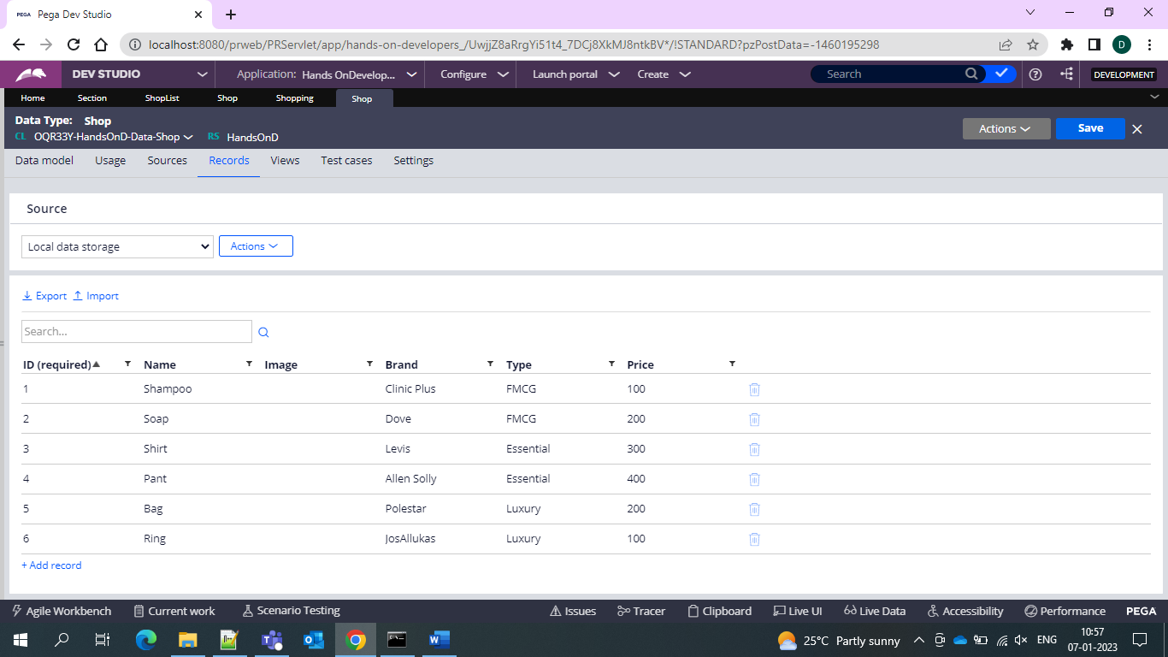

And then we created our case type and related section rules 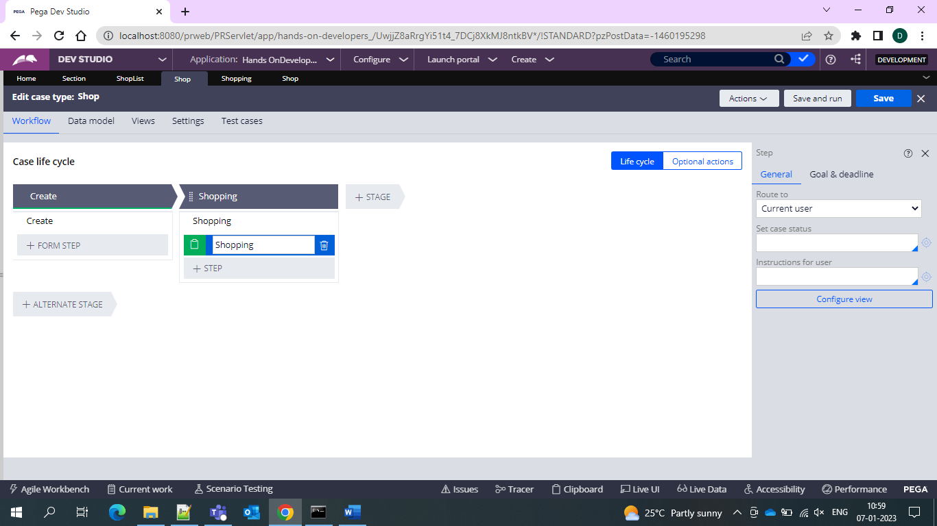

And then we get the and In our section rules we are using the slider for min price and max price

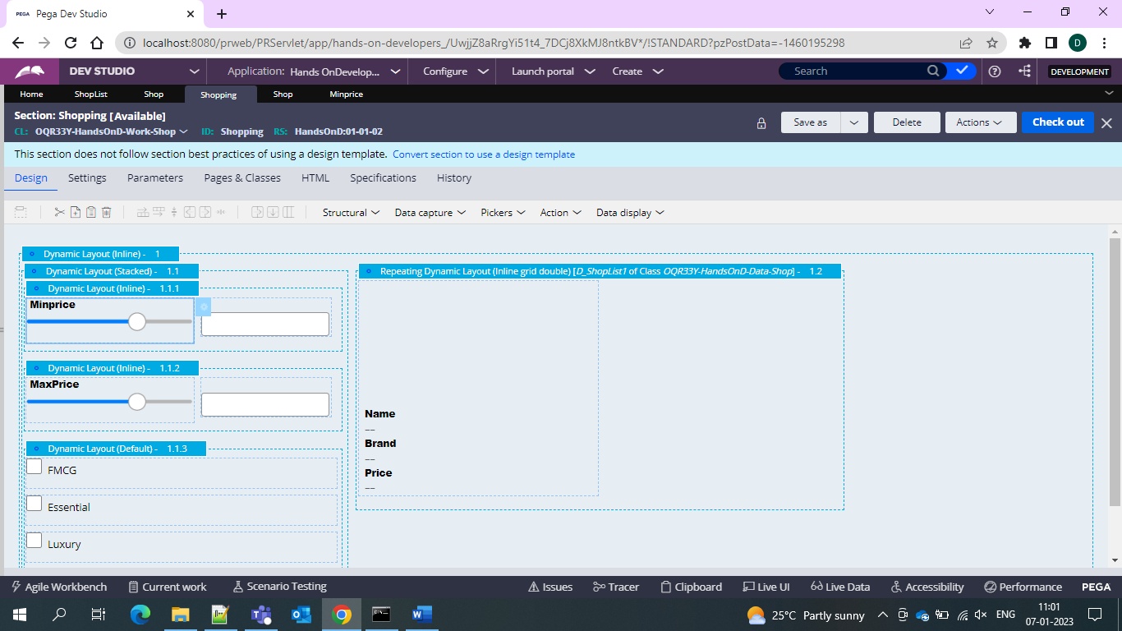’and inside the slider created the properties for min and max price 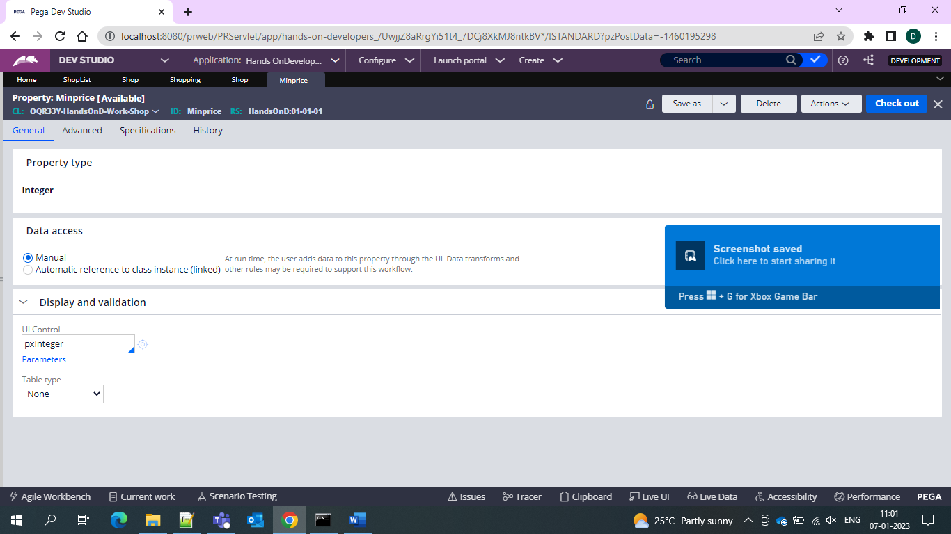

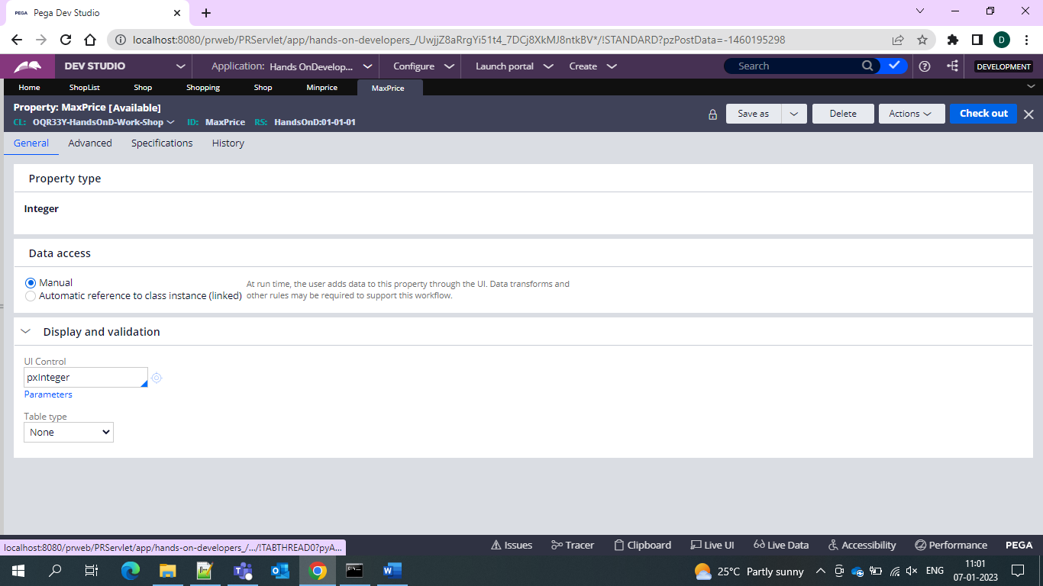

And then used one text field box for displaying the number do I used action set for setting value and assigning the values of the min an dmax price to one OOTB integer and double property to store the values of the min and max price

And on the text box we refer the OOTB properties

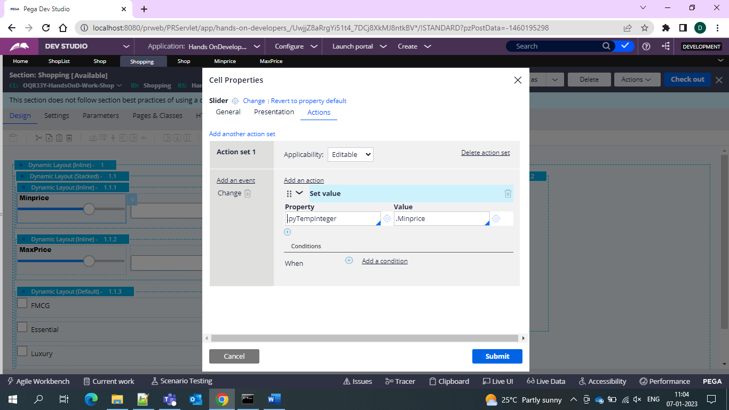

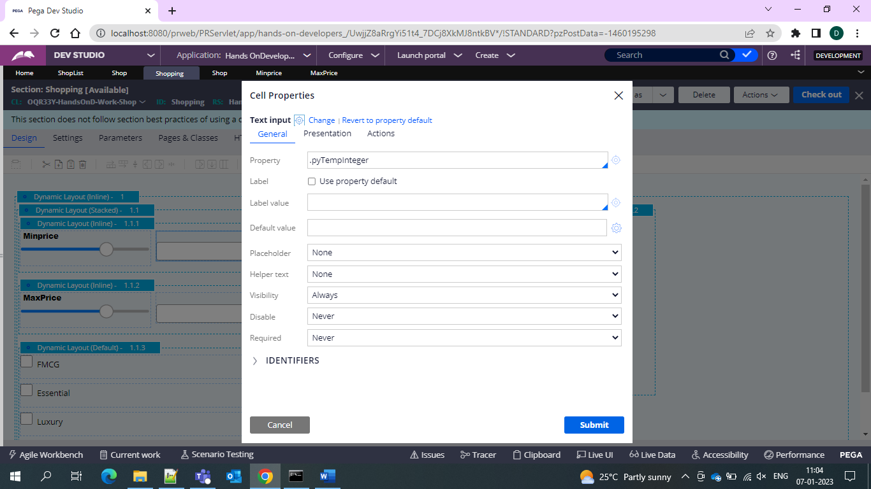

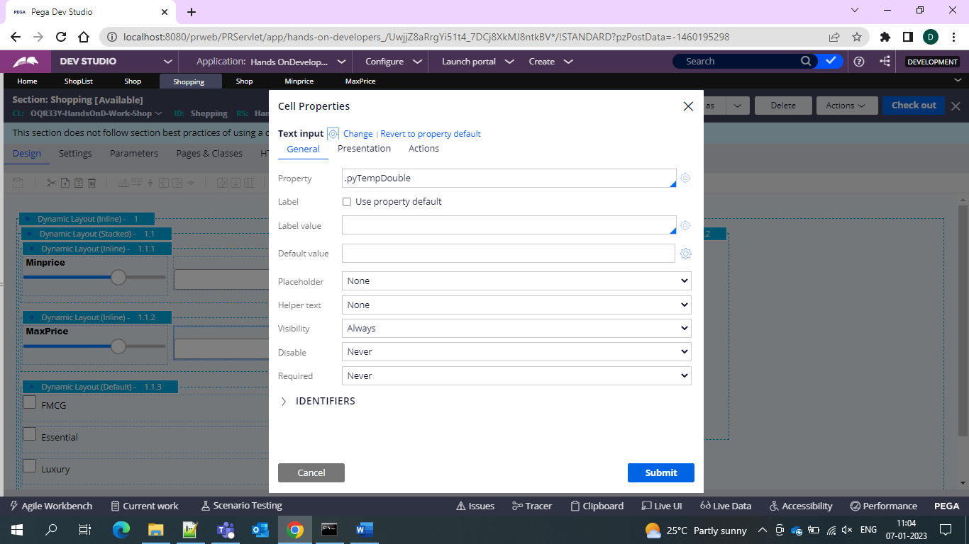

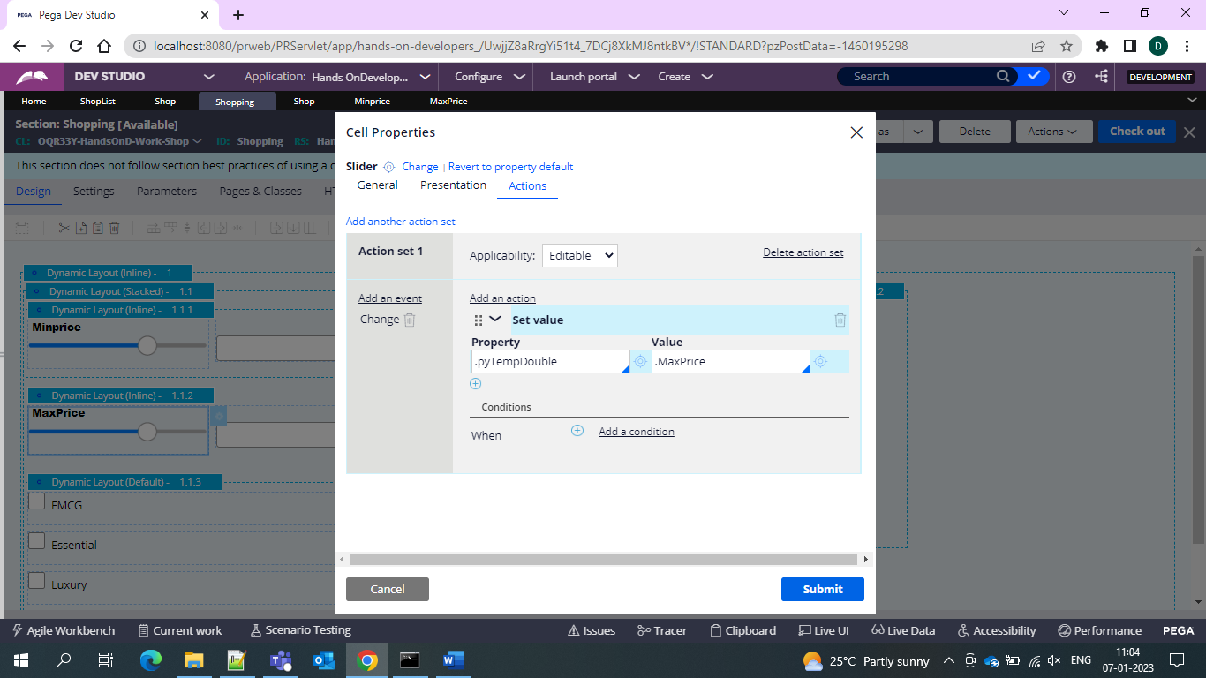

And now under one DL we use the Type properties for determining the type

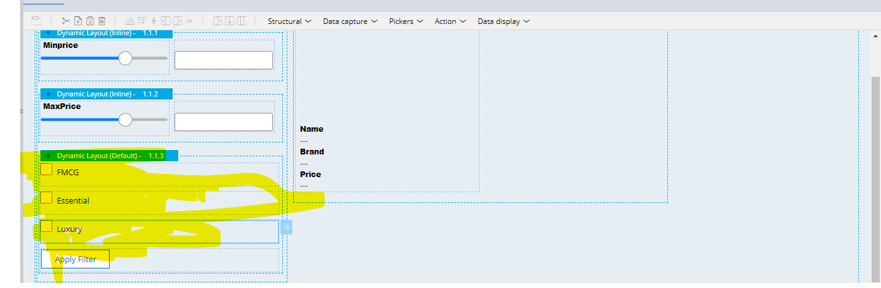

And under that we use checkbox since they are true/false properties

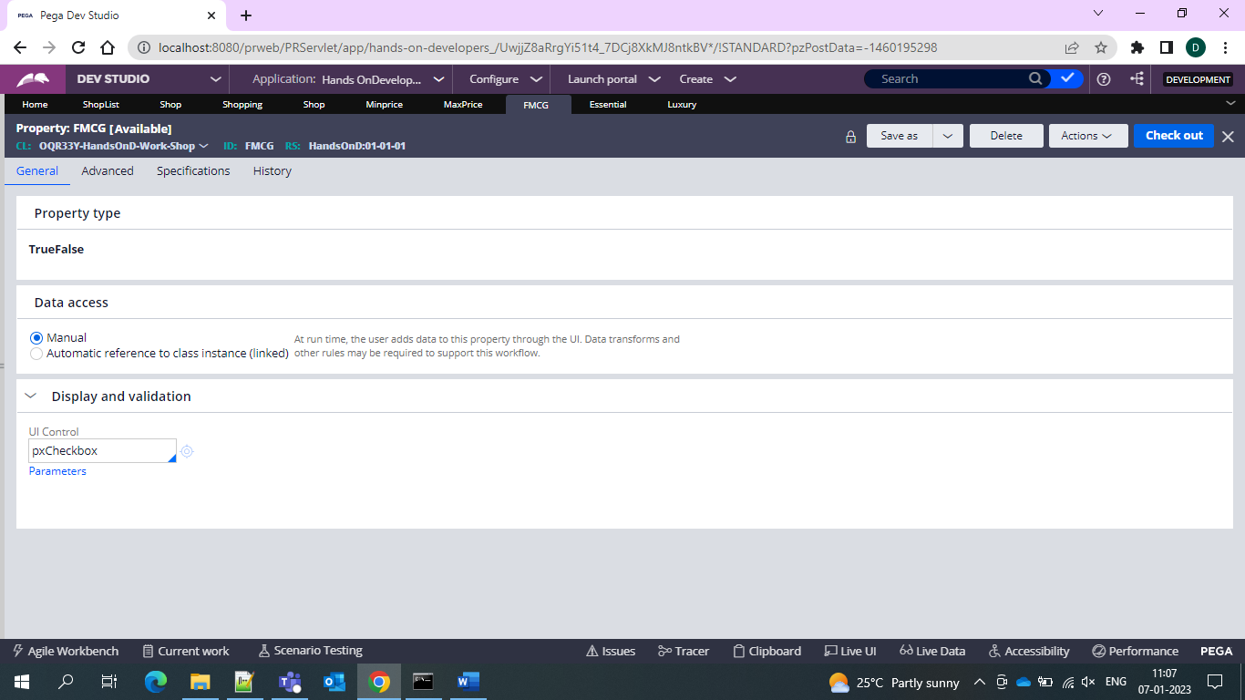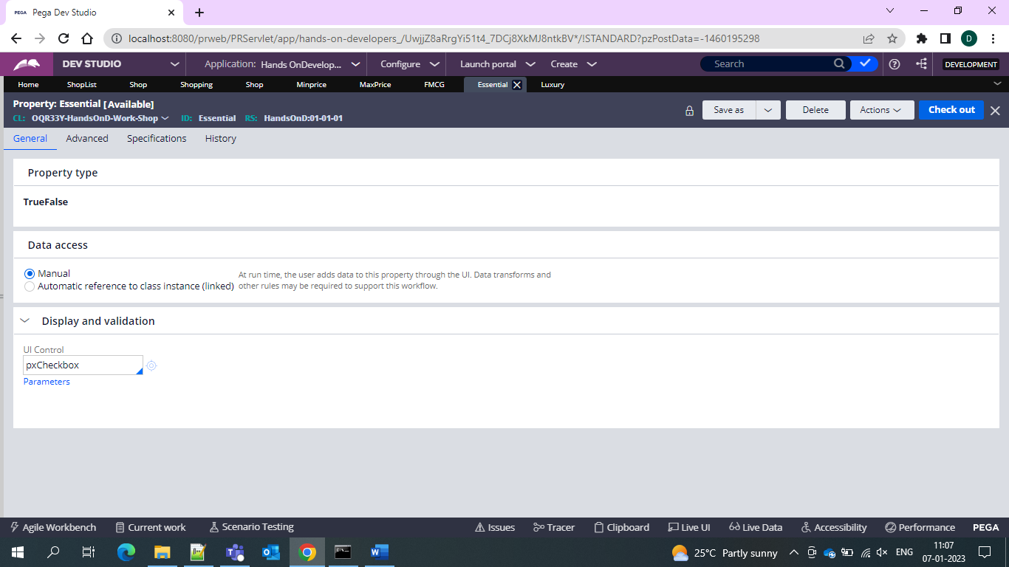

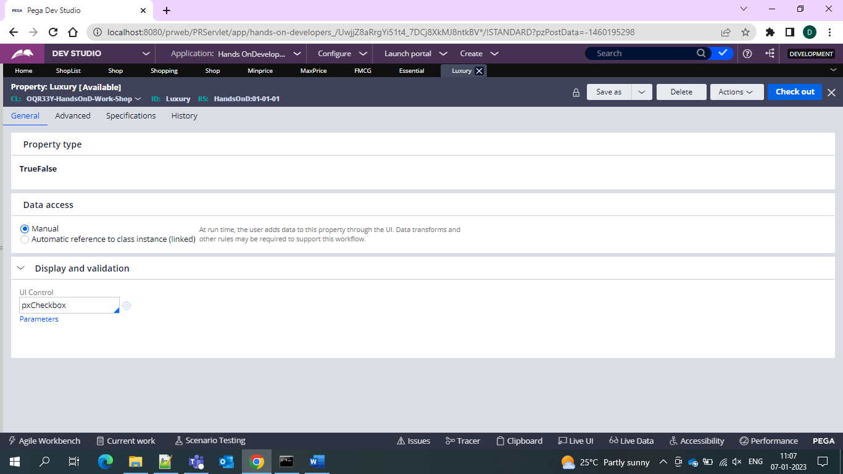

And now all the 3 propertieds we use action set and run one DT so that related products are shown

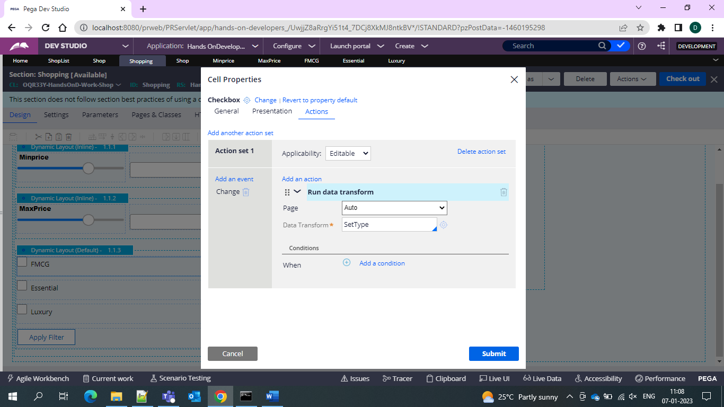

The same config used for 3 checkboxes now under the DT

First we set the type = Blank and then we use the

When conditions = true then set the type = essential/luxury

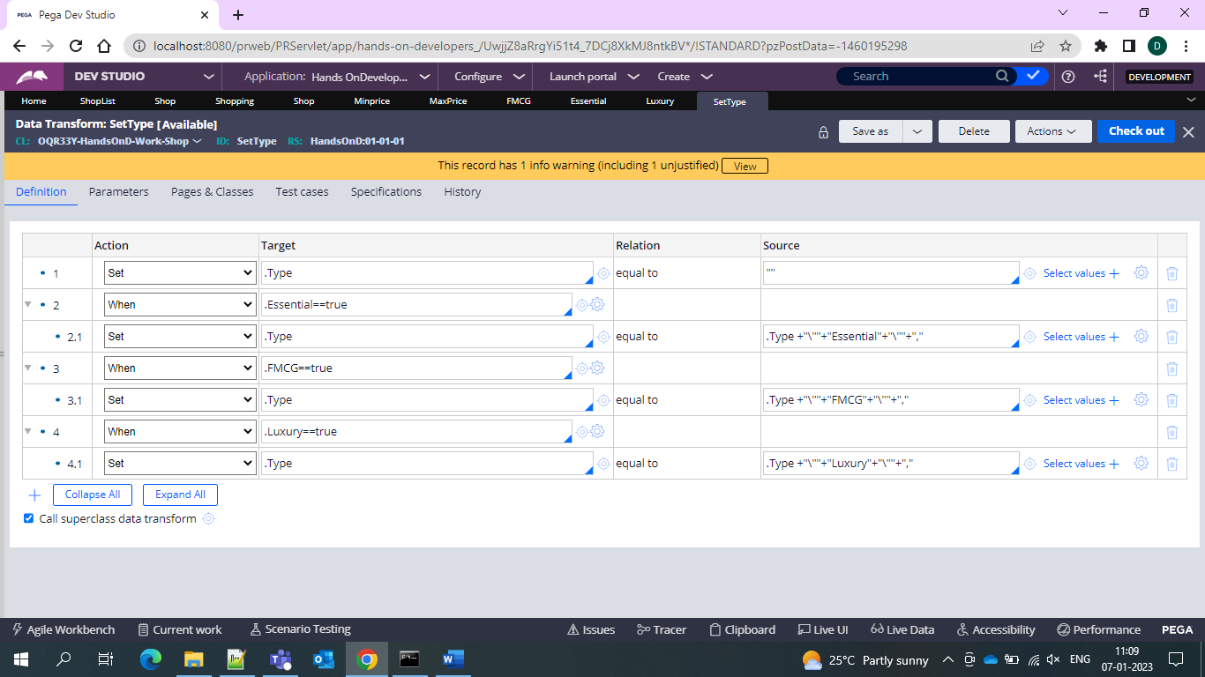

And now here we are giving the same in the DT and after that we create one more section and give the prodfucts that we need to display

On click of these checkboxes 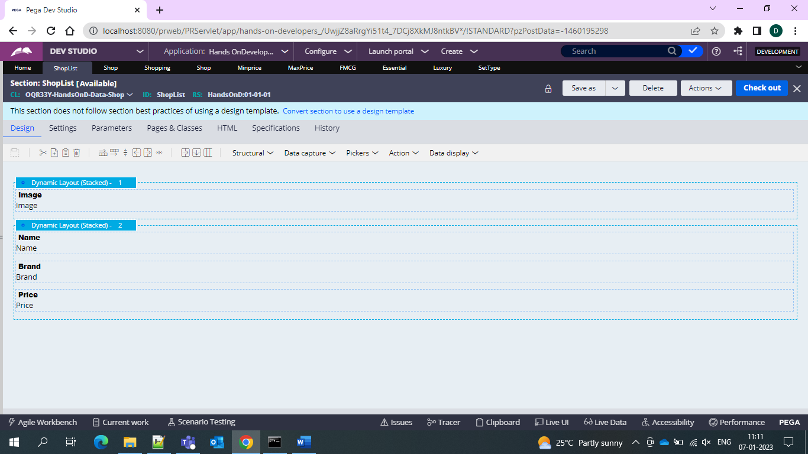

Which is directly from the data type that is the properties

And now we emnbeed the section and give it under the dynamic layout

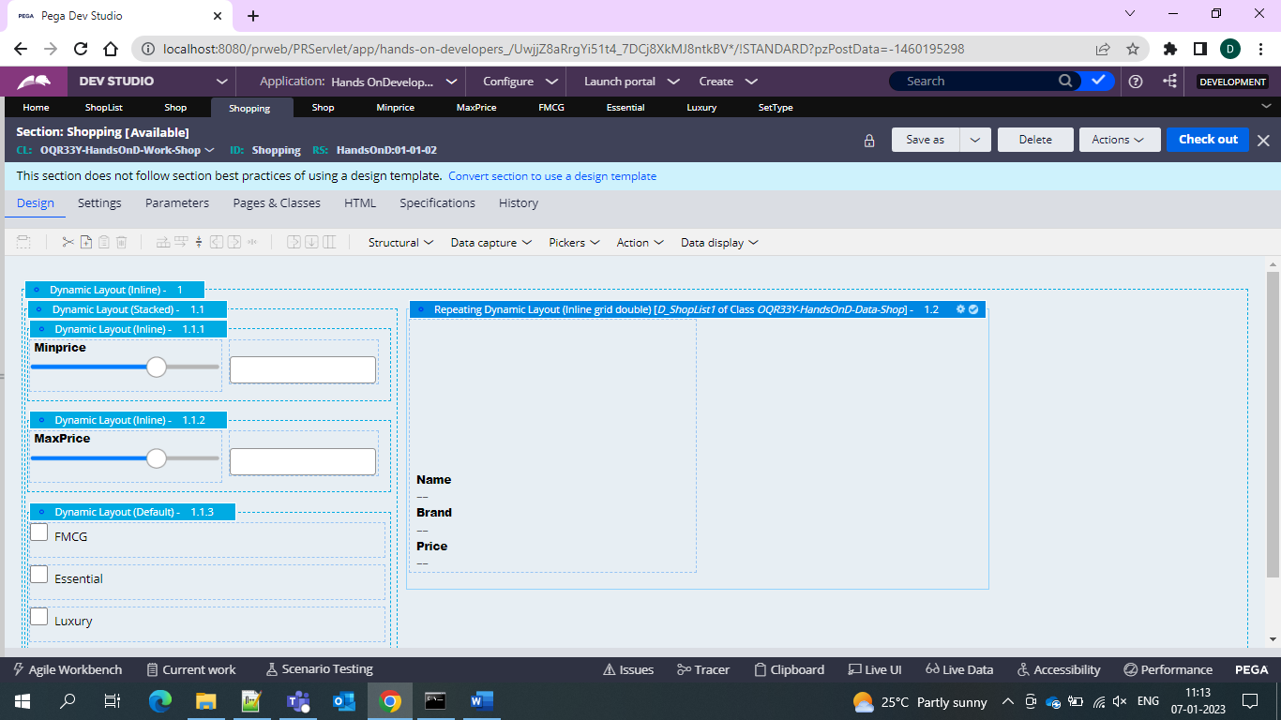

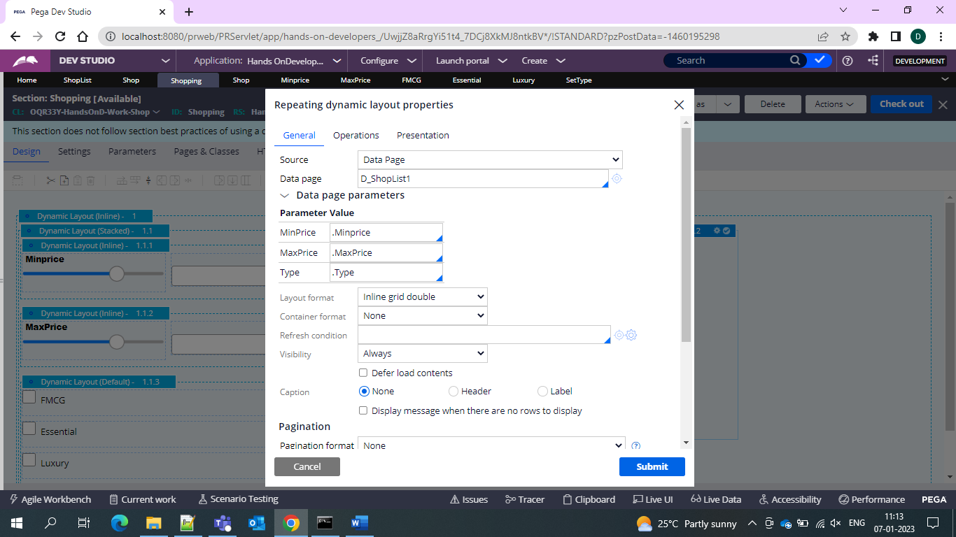

And the list data page of the data type is refereed here and also for the filter of the products we created one RD with filters

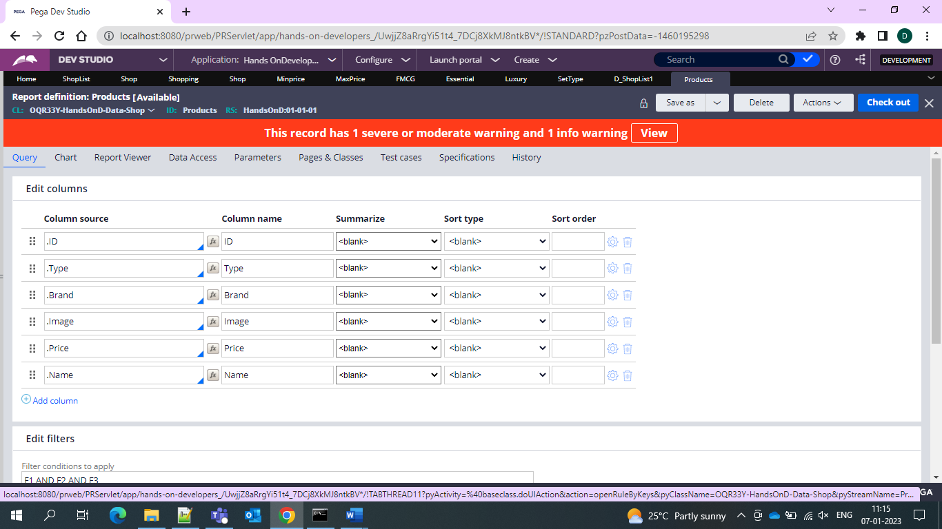

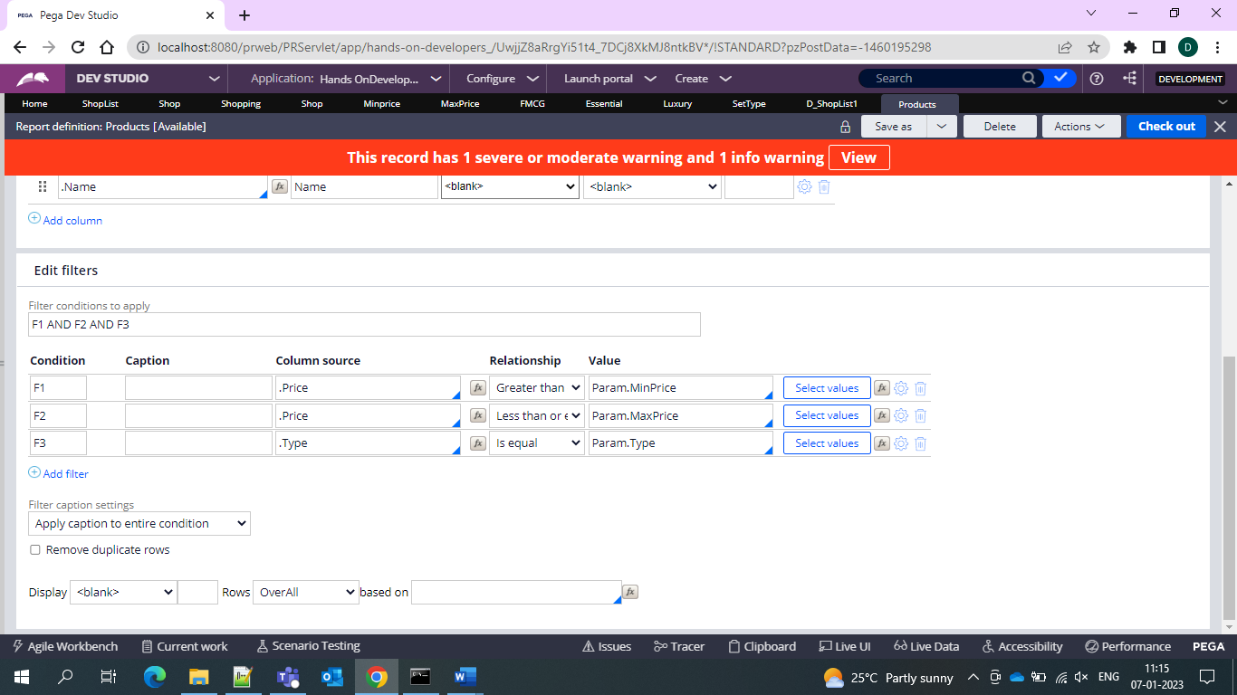

And then we use one button in the section and display refresh the section

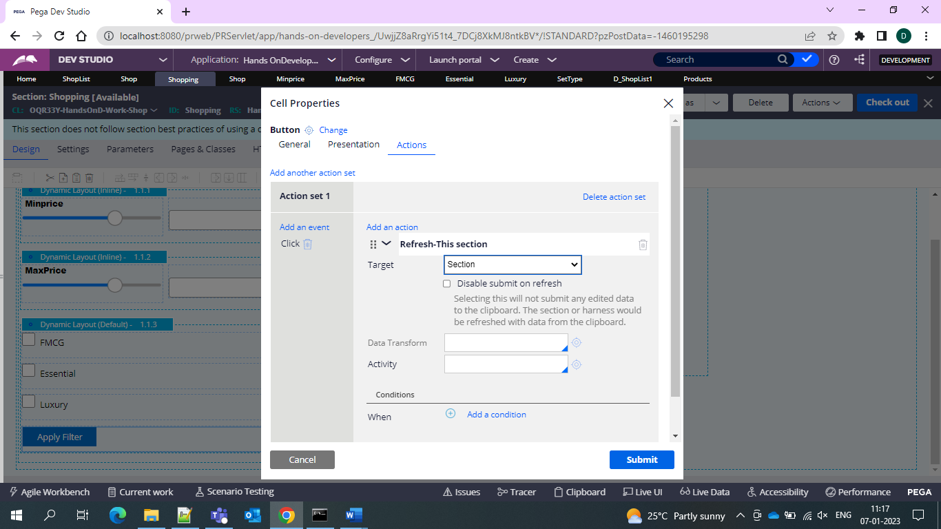

Now lets run the case and see the products as per prices

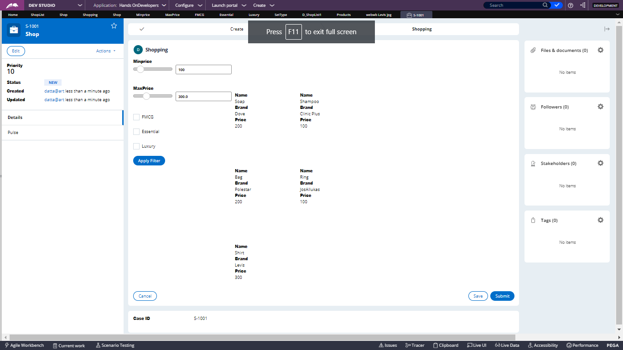

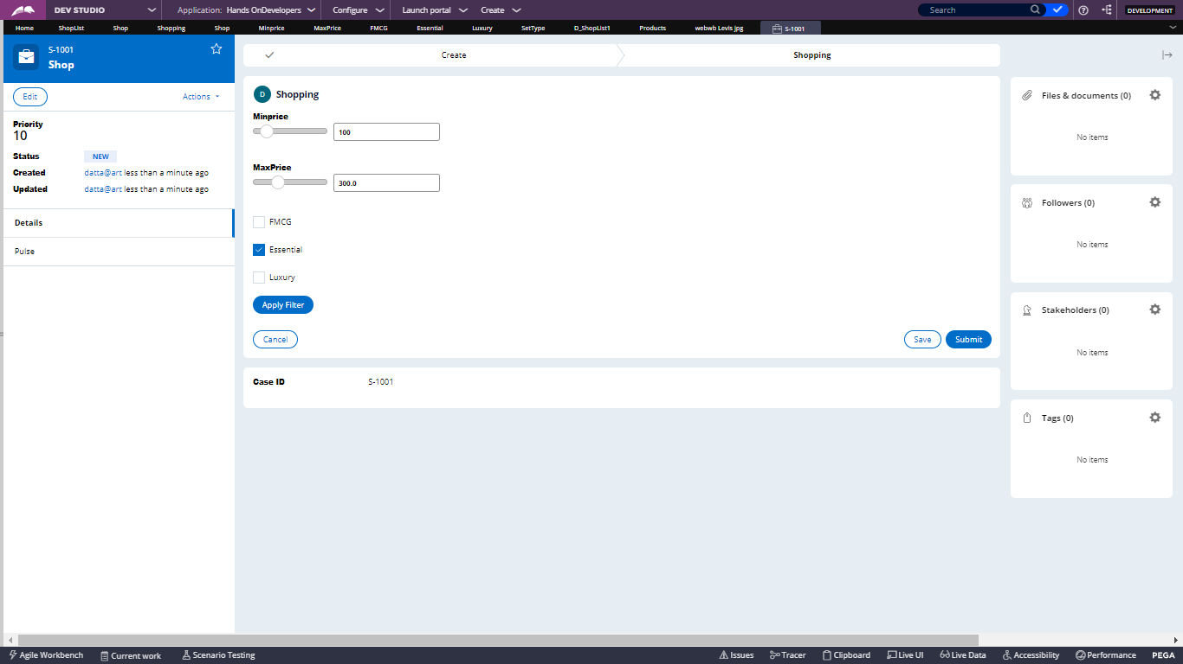

And thus the products are filtered and shown

